Beer Name: Nirvana Chanterelle
Brew Date: July 4’21
Batch Size: 10 gal
Target OG/◦P:1.083
Amnt lb/kg Ingredient
19 # Pils
4 # Golden Promise
3 # Munich
3 # Wheat
1 # aromatic or dark munich
200 g dried chanterelles

1 tsp NaCl(mash)
1 tsp NaCl(sparge)
5 tsp supercharge
2 tabs Irish Moss
15 g Yeast

Qt oz/g Hop/Seasoning Time:
42 g Saaz 60 min
86 g Saaz 30 min
86 g Saaz 10 min
Chanterelle tea 3 min
28 g cascade flame out

Stage Date
Primary: ’21
Racked: ’21
Bottled:
Kegged:
Re-Kegged:

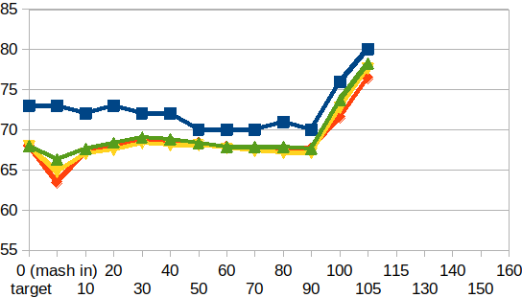

Start Time:6:30
Fill mash tun:sat
Fill sparge kettle:sat
Fire burners: 6:30am
Heat Mash Tun : Target Temp: 66-68
Heat Sparge Kettle: Target Temp: 75
Target Temp (Mash): 66-68
Grind grain: 7 ?72
Strike Temp: 68
Mash in: 8am
Temp: 63.4
Mash: Duration: 90 minutes
Start: 8 Finish: 9:30
Heat (to deactivate enzymes)
Target Temp: 75.5
Start: 9:30 Finish: 9:55
Heat Sparge H20 (Target80◦)
Sparge: Start: 9:55 Finish: 10:45am
Wort collected: full kettle
Boil : Burner On: 10:16 sugar break: 10:50 Rolling Boil: 11:05
Duration: 90 min Start: 11:05 Finish:12:35pm
Hops In: 11:35 Hops In: 12:05 Whirflock in: 12:20
Hops in : 12:25 Tea in: 12:32 hops in: flame out
Burner Off: 12:35
Rest 15 min
Pump and chill: Start: 12:50 Finish: 1:20pm
OG : 1.060?
Yeast: safale BE-256 belgian abbey
Irish Moss
Notes:

